**Bonus Assignment**

**Cosine Similarity**

**Example for what you should do:**

**Calculate the cosine similarity of the two documents given below.**

* **Document 1 = 'the best data science course'**
* **Document 2 = 'data science is popular'**

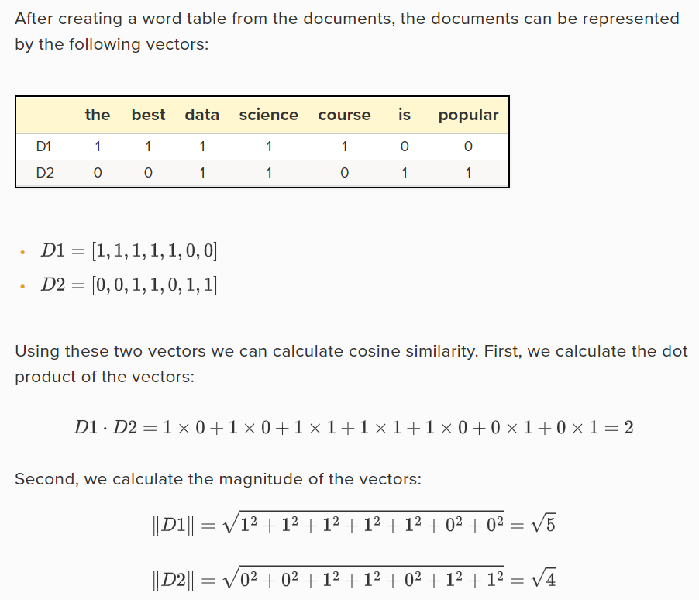

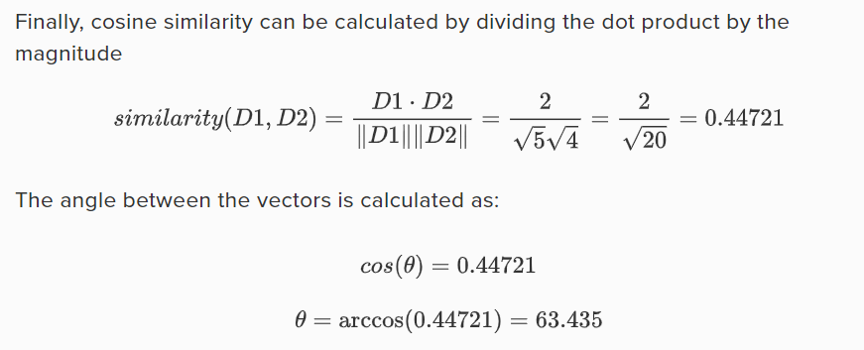

You are required to measure the cosine similarity between four documents and bring the similarity score sorted descendingly. (More similar to the least similar) (documents of assignment1 that you used before)

**Example of the output required**

D1 and D2 cosine similarity = 0.9

D1 and D3 cosine similarity = 0.8

D1 and D4 cosine similarity = 0.7

D2 and D3 cosine similarity = 0.6

D2 and D4 cosine similarity = 0.6

D3 and D4 cosine similarity = 0.4